Title of the manuscript
Angie A. Smith¹, B. Bradley Miller¹, Carl Carter²
¹Department example, University example, city, postal code, country
²Laboratory example, city, postal code, country
Correspondence to: Angie A. Smith (angie@email.com)
Abstract. Please use only the styles of this template (MS title, Authors, Affiliations, Correspondence, Normal for your text, and Headings 1–3). Figure 1 uses the style Caption. The abbreviation “Fig.” should be used when it appears in running text and should be followed by a number unless it comes at the beginning of a sentence, e.g.: “The results are depicted in Fig. 5. Figure 9 reveals that.” Figures and tables as well as their captions must be inserted in the main text near the location of the first mention (not appended to the end of the manuscript). Regarding colour schemes, it is important that your maps and charts allow readers with colour vision deficiencies to correctly interpret your findings. Please check your figures using the Coblis – Color Blindness Simulator and revise the colour schemes accordingly.

1 Section (as Heading 1)
Suspendisse a elit ut leo pharetra cursus sed quis diam (Smith et al., 2014; Miller and Carter, 2015). Nullam dapibus, ante vitae congue egestas, sem ex semper orci, vel sodales sapien nibh sed lectus. Etiam vehicula lectus quis orci ultricies dapibus. In sit amet lorem egestas, pretium sem sed, tempus lorem.

1.1 Subsection (as Heading 2)
Quisque cursus massa sed urna congue, ac convallis neque consectetur. Proin faucibus neque non metus mollis, suscipit pretium nisl blandit. In hac habitasse platea dictumst.

1.1.1 Subsubsection (as Heading 3)
In placerat dictum urna ut interdum. Proin faucibus neque non metus mollis, suscipit pretium nisl blandit. In hac habitasse platea dictumst. Nam laoreet augue eu odio eleifend, non posuere quam pulvinar. Integer sit amet leo vitae nisl facilisis tristique calculated following Eq. (1):
$Y=\frac{∆M_{0}}{∆\left[\text{isoprene}\right]}$ , (1)
where $∆M_{0}$ is Ut rutrum, sapien et vulputate molestie, augue velit consectetur lectus, bibendum porta justo odio lobortis ligula. In in urna nec arcu iaculis accumsan nec et quam. Integer ut orci mollis, varius justo vitae, pellentesque leo. Ut.

1.2.2 Subsubsection (as Heading 3)
In pharetra massa dictum gravida scelerisque. Sed vitae purus eget purus tincidunt accumsan ut at magna.

2 Section (as Heading 1)
Sed ullamcorper venenatis quam, ut aliquet augue iaculis quis. Mauris at elit quis magna cursus accumsan non vel nisi. Aliquam felis ipsum, interdum sed massa id, efficitur eleifend est. Pellentesque convallis, metus vel mattis molestie, ipsum diam pulvinar lorem, eget interdum urna sem et leo.

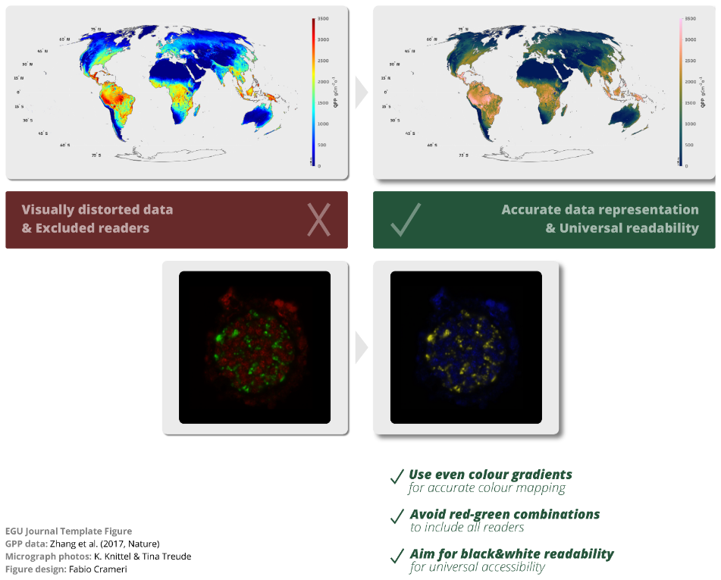
Figure 1: An example for accurate data representation & universal readability of figures.

Nullam at posuere quam, ut tincidunt ante. In a elementum mauris. Lorem ipsum dolor sit amet, consectetur adipiscing elit. Donec facilisis mauris ante, ac accumsan augue venenatis et. Duis feugiat lacus gravida pulvinar finibus. Maecenas a sapien vel velit posuere lobortis a eu mi. Fusce id turpis hendrerit, tempor neque ut, auctor ante.

References
Miller, B. B. and Carter, C.: The test article, J. Sci. Res., 12, 135–147, doi:10.1234/56789, 2015.
Smith, A. A., Carter, C., and Miller, B. B.: More test articles, J. Adv. Res., 35, 13–28, doi:10.2345/67890, 2014.

